- Watch the video again and fill in the gaps.

- An………………………………….works in a theater.
- An…………………………..……. uses paints.
- A …………………………………..works at a bakery.
- A…………………………..……….is always busy.
- A…………………………………….uses wood.
- A…………………………………….works at a restaurant.
- ……………………………..……… fly airplanes.
- A …………………………………….serves food.
Watch the video and fill in the gaps
http://www.youtube.com/watch?v=HwW3PgxzFiw
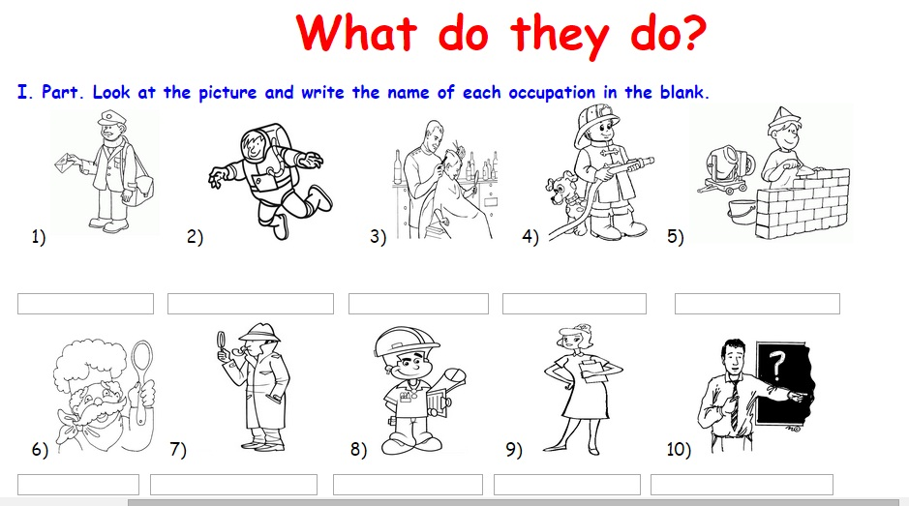

TIME TO PLAY
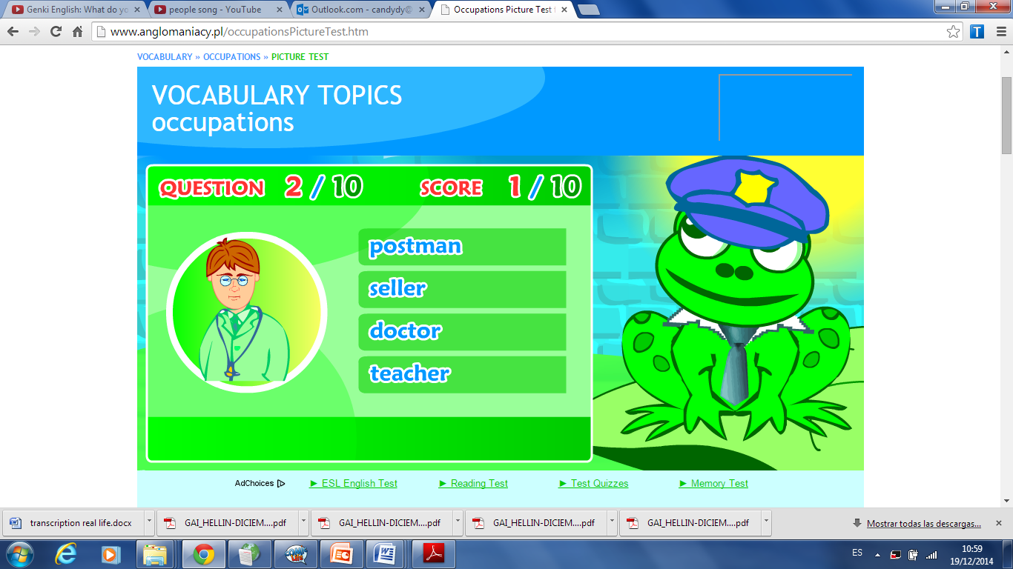
http://learnenglishkids.britishcouncil.org/en/spell/the-super-jobs

http://www.anglomaniacy.pl/occupationsPictureTest.htm

Exercise 1: Read and correct the sentences:
LIFE IN A MEDIEVAL CASTLE

Medieval castles were homes and fortresses. Castles were often on the top of hills or rocks. This helped to see enemies.
Parts of the castle:
Many castles had thick walls, small windows and high towers. They also had dungeons to keep prisoners in. Many castles had a moat of water and people used a drawbridge to cross the moat. They entered the castle through a big gate.
People in the castle:
Many different people lived in the castle. These included the lord and the lady of the castle, and their family. Knights, cooks, servants and guards also lived in the castle. Sometimes musicians and acrobats visited the castle and performed shows. Many animals, such as dogs and chickens, lived in the castle, too. The castle was a busy and noisy place.

1- Sometimes the lord and lady performed shows.
2- Knights, cooks, servants and guards also lived in the moat.
3- Castles were often near hills or rocks.
4- Many castles had thin walls and big windows.
5- People used a boat to cross the moat.

Exercise 2: Think and say:
1- Are there any medieval castles in your country?
2- What was it like to live in a medieval castle?
3- Is life easier or more difficult today?

