HELLO REINDEER parquesur.inglés jimdo
NAME________
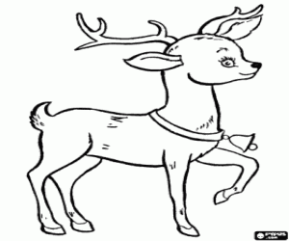
Hello reindeer,
Hello snowman,
Hello Santa
Happy holidays
1-2-3-4-5-6-7-8-9-10
Merry Christmas everyone,
Let´s sing it once again
Hello reindeer,
Hello snowman,
Hello Santa
Happy holidays
Happy holidays

